**Camera Player**

**Make sure that you have unzipped the zip file that you have downloaded from the link**

**1)** Click on the CameraPlayer icon to begin

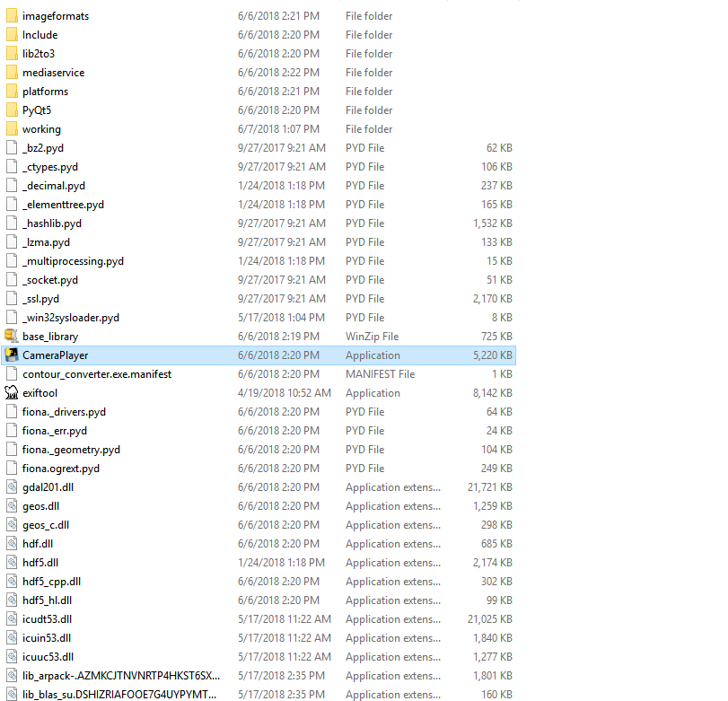

**2) Uploading a video**

**a)** Click on the Upload Video File Option

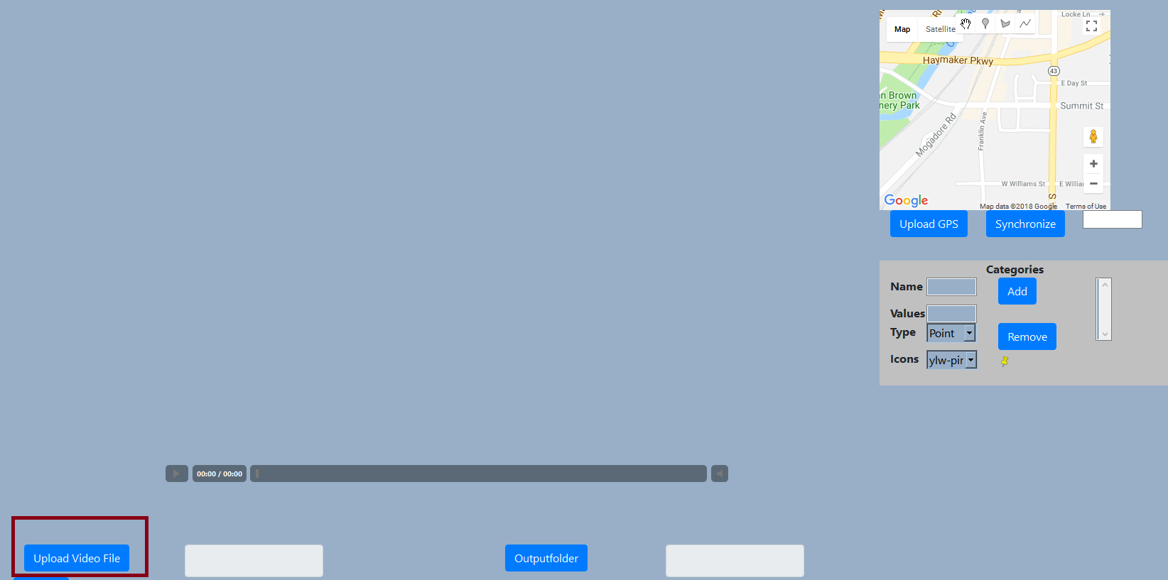

**b)** Select the required video file

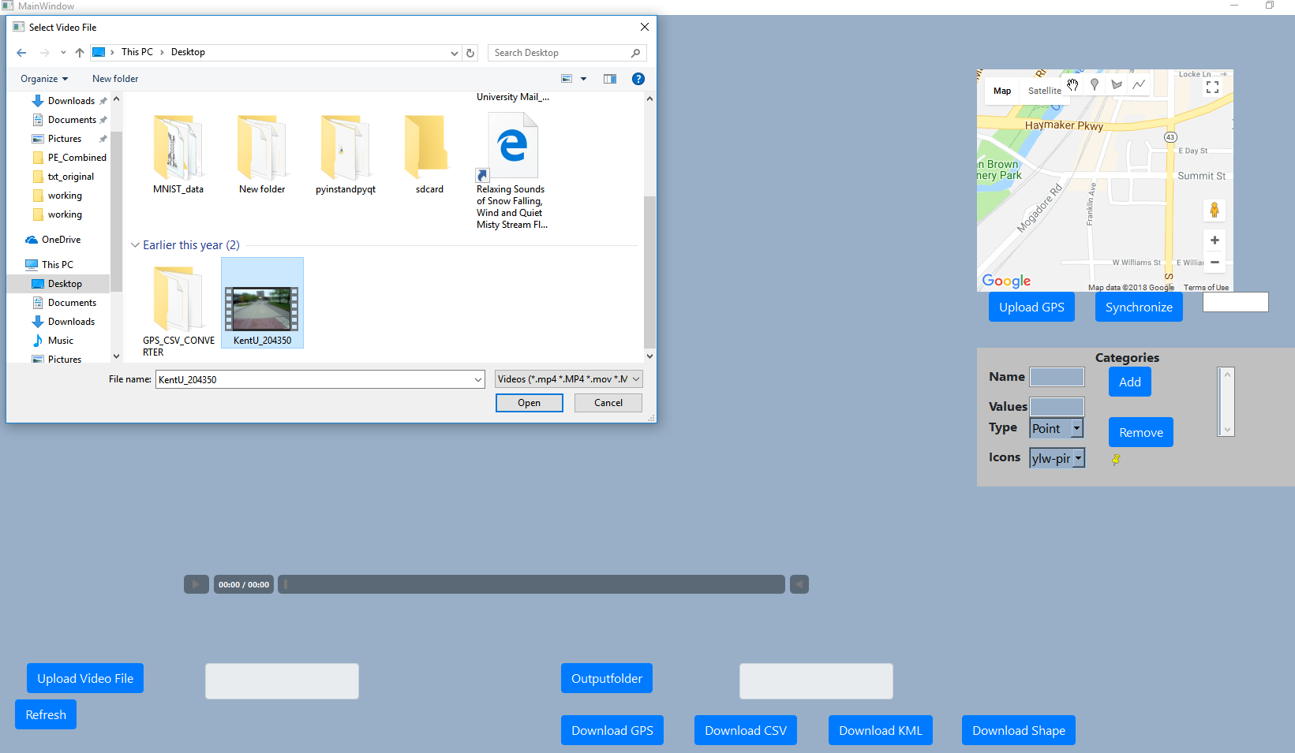

**c)** If the video has GPS content then along with the video, the GPS will be displayed in the map

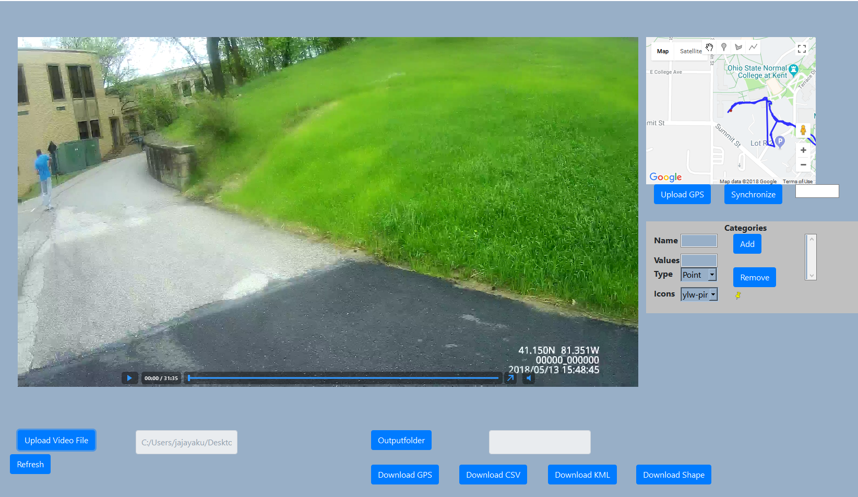

**d)** If the video gets stuck while dragging the seek bar, use the **Refresh** button at the bottom of the page

**e)** The map is interactive and if you click on the path, the video will move to the corresponding location.

**3)** Download as CSV or GPS (Gpx)

a) Set the output folder first (this may be done only once) by clicking the Outputfolder

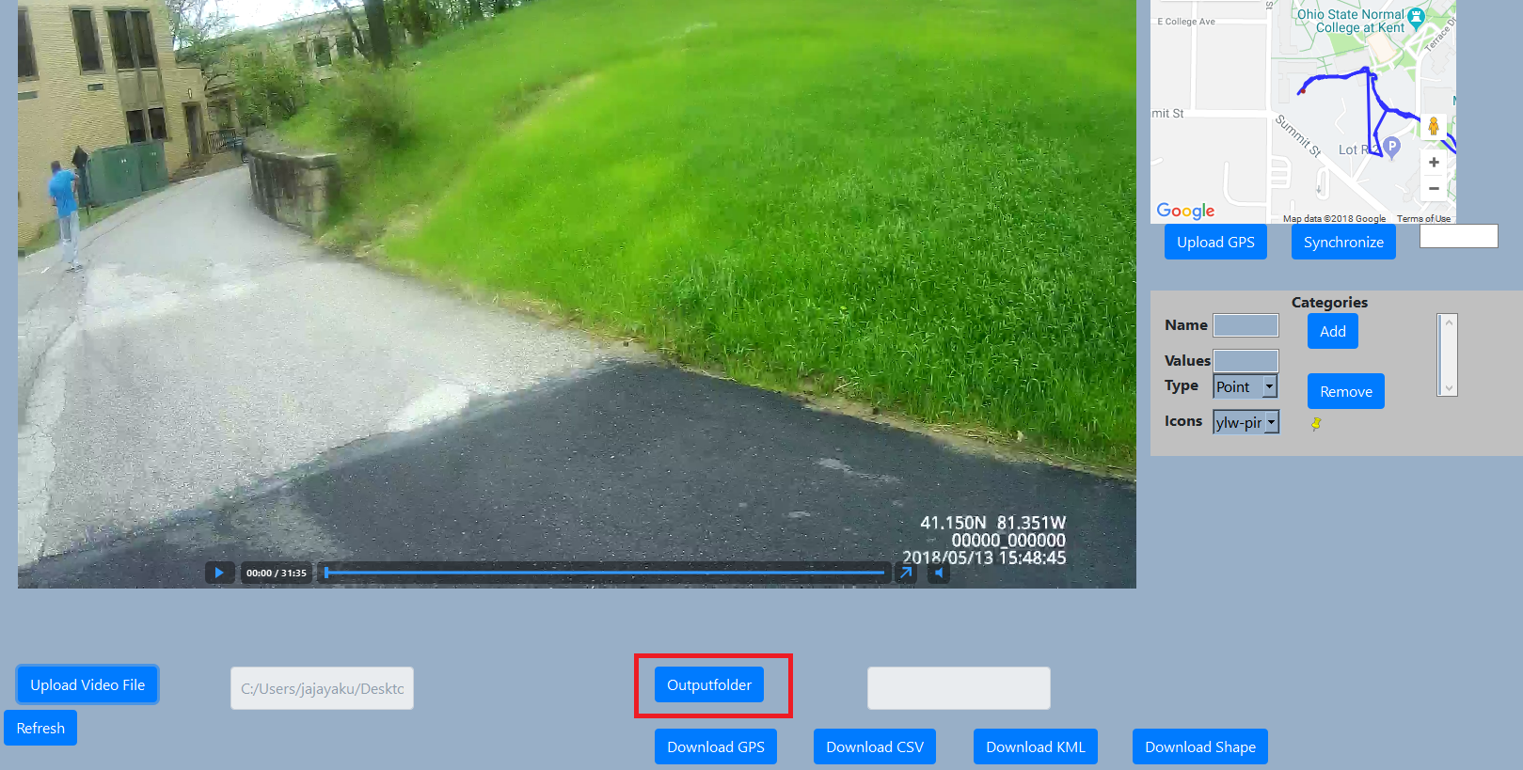

b) Select the folder where the output’s will be downloaded

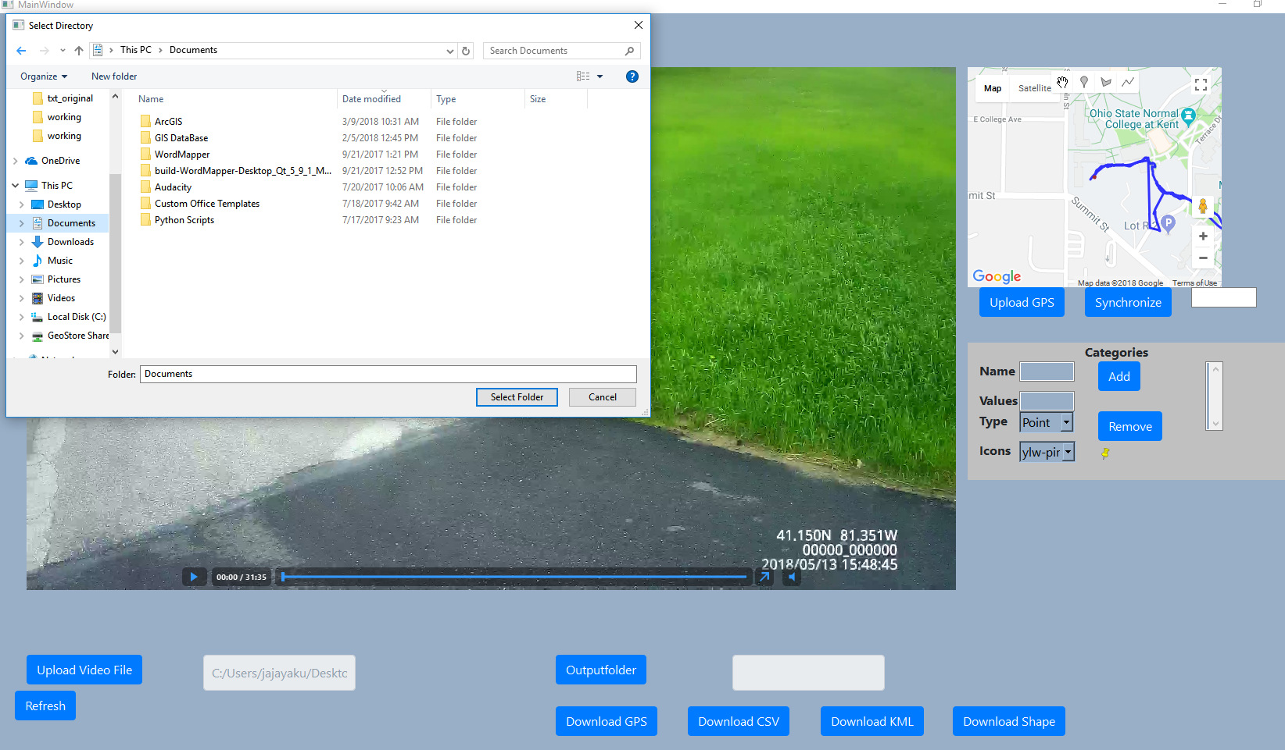

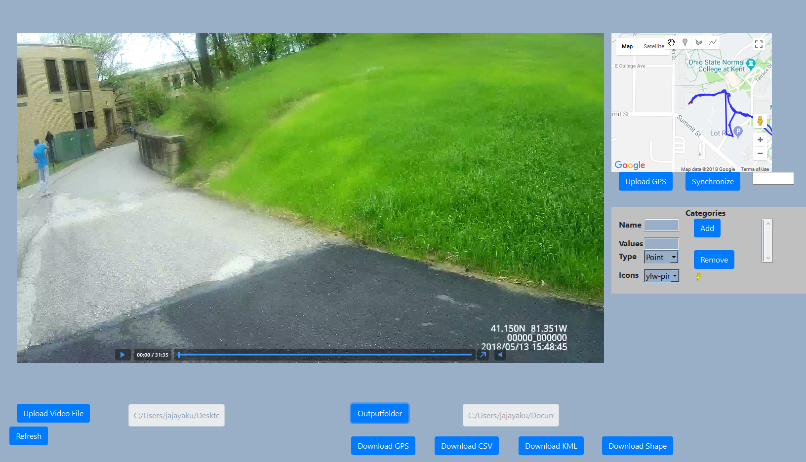

c) Click Download CSV or download GPS

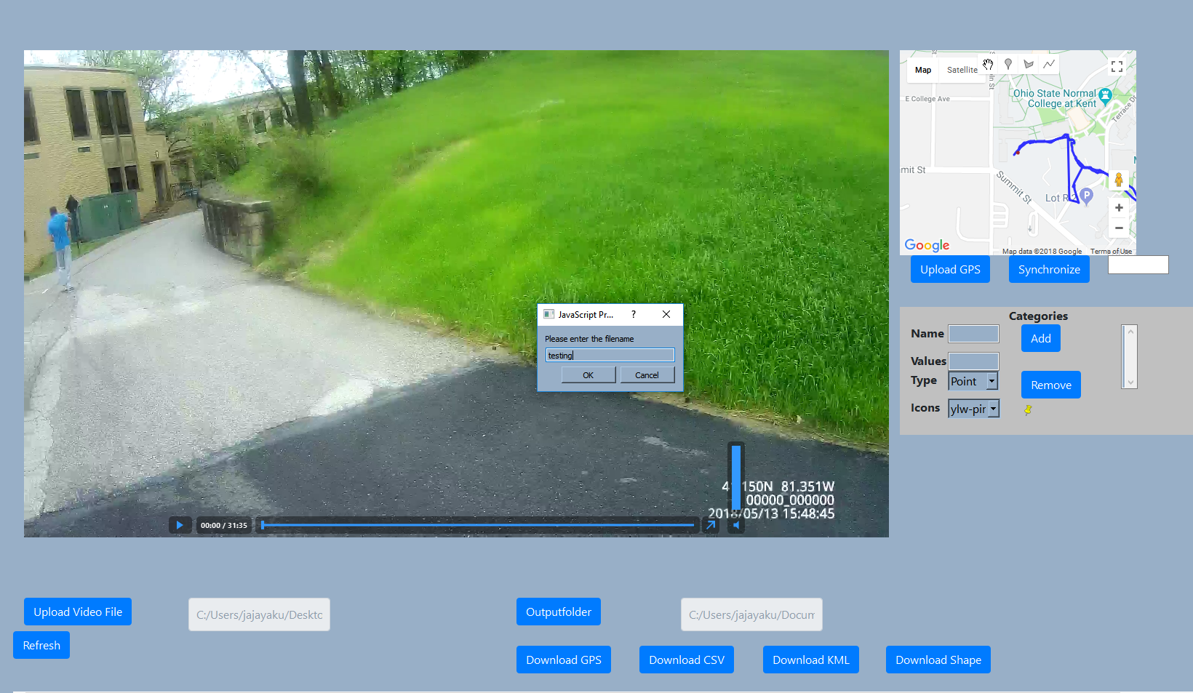

The file will be downloaded in the output folder

**Creating Spatial data (Digitizing)**

Three different types of vector data can be added to the map including point, line, and polygon. The example below shows how to create a new category, assign values to it and then generate spatial data based on the newly created category.

1. Creating a category

New category can be created using the category option window available on the right pane of the software

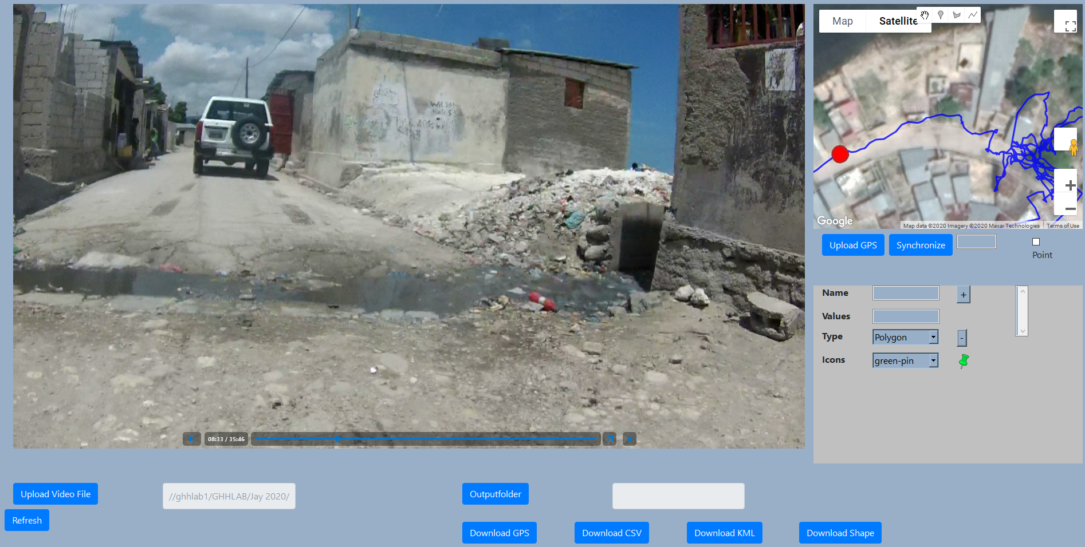

1. Creating a point category trash and assigning optional values 1,2,3,4,5 to it. A green color pin is added for this category

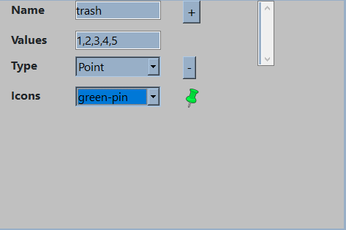

Click on the “+” button to add this category. Once it is added the category will be shown in the selection drop down

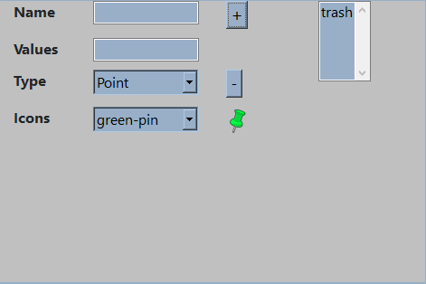

To remove this category, click on the “-” button after selecting the category from the selection drop down

1. Adding a point to map and assigning the category trash to it with a value of 3

Click on the marker option available with the map

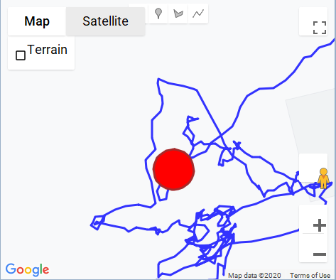

This will change the “hand” cursor symbol to a ‘+’ symbol

Identify the place where you want to drop the pin and click on that location in the map

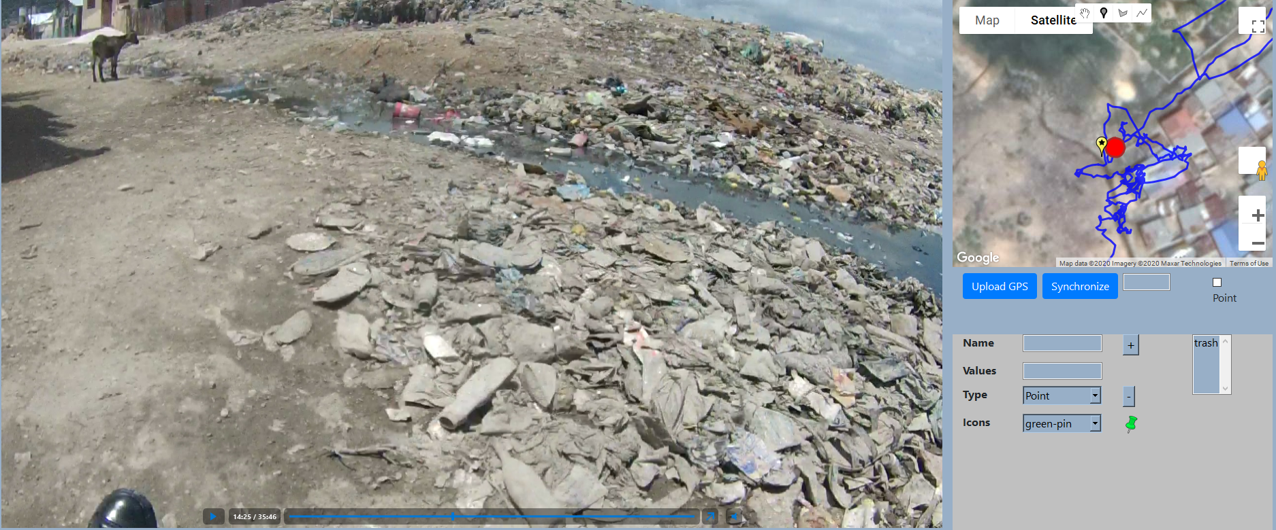

This will create a generic marker at the clicked location.

To edit the marker and assign a category, click on the newly created marker (this should be done after switching back to the “hand” symbol). This will generate a dialog box with category selection options

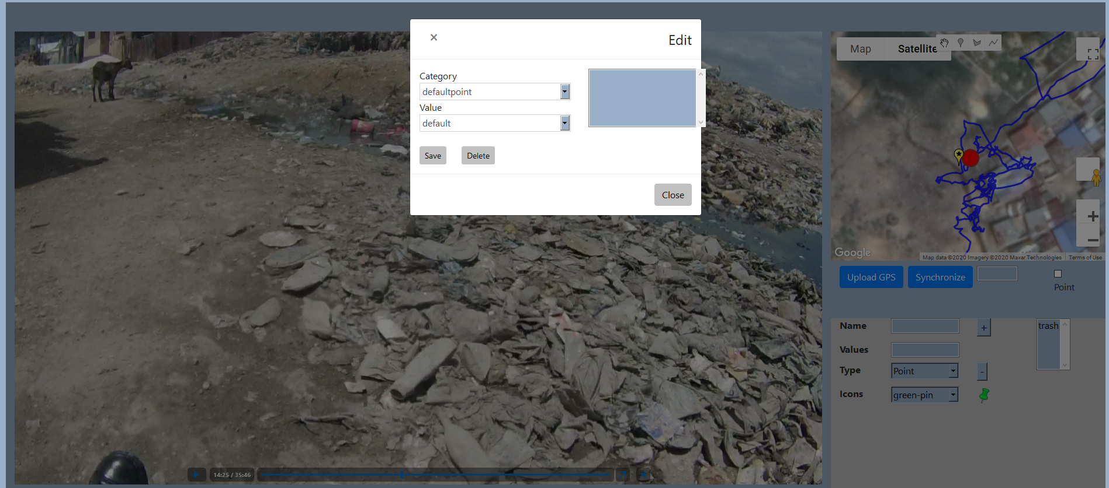

Select the category from the drop down, the value and an optional free text

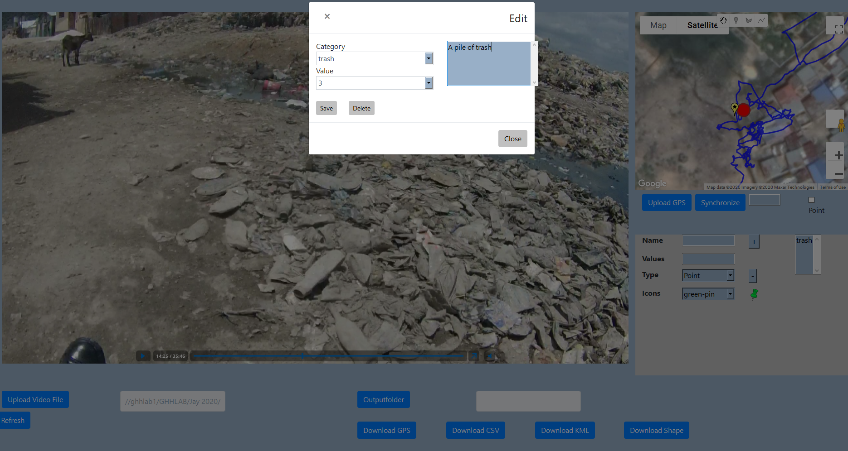

Click save to add the point to map or remove to delete the point

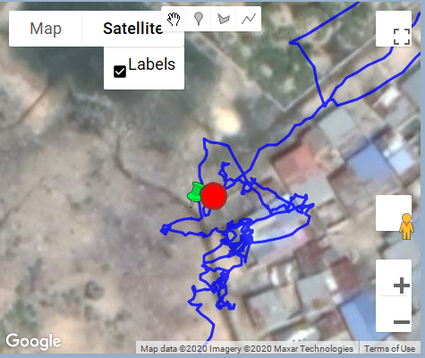

1. Adding a polygon with category name “drain” having values small, medium, and large to the map

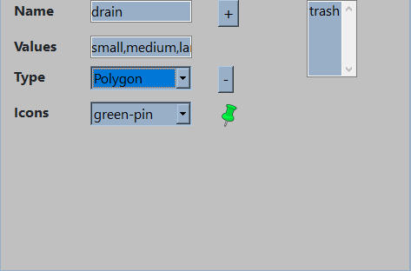

1. Adding a polygon drain to the map

Select the polygon option from the toolbar

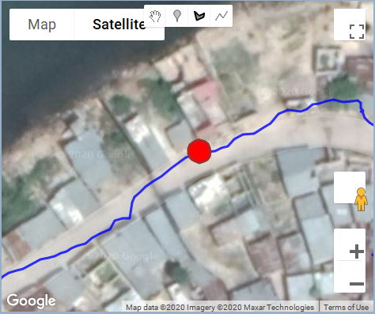

**Draw the polygon**

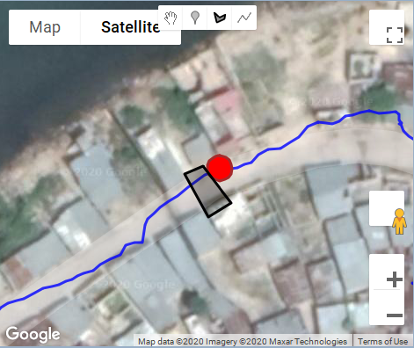

Click on the polygon to edit the category (change to hand symbol before clicking on the polygon)

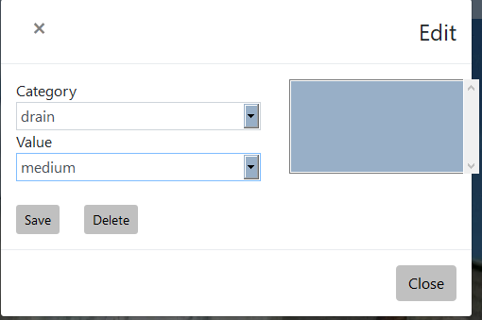

After digitizing the user can click on either download as shape or download as kml to generate new spatial data